Blofield and Blofield Heath Annual Meeting of the Parish

Minutes of the Annual Parish Meeting of Blofield and Blofield Heath, held at Blofield Courthouse on Wednesday 14th March 2024 at 7:30pm

PRESENT
Sarah Dhesi (vice-chair) and the clerk, Sarah Osbaldeston presided.
Blofield Parish Councillors present –Yvonne Burton, Paul Culley-Barber
Sixteen Parishioners were present. District Councillor Paul Newstead was present.

- WELCOME
Sarah Dhesi, Vice-Chair of the Council welcomed everyone.

- A PRESENTATION FROM ALISTAIR WILSON, SENIOR PROJECT MANAGER AT PENTACO CONSTRUCTION LTD, ALISTAIR WILL BE SPEAKING ABOUT THE DEVELOPMENT PLANS FOR THE NEW SCHOOL AND WILL BE AVAILABLE TO ANSWER ANY QUESTIONS
  - Detail of the school build project was presented and discussed including community engagement on Pentaco will make with the parish, such as a steel framing signing event and hard hat decorating day.

- TO AGREE THE MINUTES OF THE ANNUAL PARISH MEETING HELD ON ^{8th} MARCH 2023
  - These were approved by all present and duly signed by the Chair.

- CHAIR / COUNCIL’S REPORT
  - Unfortunately, I can not attend this evening due to personal commitments, but here is my report.
  - The past year has seen a number of projects take some steps forward albeit not as rapid as the Council would have liked but we have also seen some major projects completed.
  - The Council remains 4 Councillors short, but is endeavouring through various contacts and resources, to attract more Councillors and would particularly welcome anyone from Blofield Heath or of a younger demographic reflecting the changes in our Parish over recent years. As always, the Council welcomes residents of all backgrounds and training is provided.

Planning
  - The number of applications continues to be at a lower level than we have seen in recent years. Certain developments again continue to cause concern with the Council, particularly in Blofield Heath and especially in relation to the risk of increased flooding caused by new developments. The Council attempts to represent existing resident’s concerns by commenting strongly on applications and at Planning Committee, where appropriate, with Broadland District Council Planning who is the deciding authority.
  - The Council also continues to lobby on community related ‘conditions’ of bigger planning applications that don’t appear to materialise when they should, such as footpaths along the Woodbastwick Road, and along the Yarmouth Road. The first is now in progress, the second is still being lobbied for, along with Brundall PC also with the support of District Cllr. Paul Newstead.

Finance
  - The Council has raised the precept this year in line with inflationary pressures given that the Council is not protected from increases from suppliers and contractors experienced by the wider population and businesses.
  - The Council continues to financially support, amongst other smaller initiatives:
- The community land at Marty’s Marsh.
- Blofield Allotments
- Maintenance of the churchyard at St. Andrew & St. Peter -with regular tree works and headstone safety checks with work commencing later in the year on restoring the church wall.
- Continuing maintenance of the various green spaces throughout the Parish, and gradually adopting more areas of land, as a result of the land transfer from Broadland District Council within the Wyngates residential area.
- Cutting of the grass verges within the Parish.
- Awarding small grants to support the warm hub within the Library
- The Courthouse, a listed building, owned by the Parish Council and invaluably supported by a dedicated management committee. During the last year the Council has had significant expenditure on the total refurbishment of the cupola that sits atop the building and has undertaken some maintenance activities during the year including but not limited to:
  - Re-pointing works to tired and worn-out brickwork.
  - Replacement of key elements of guttering and gutter clearing.

Grants
The council are always looking out and applying for Grants to make the precept go further.
Recent successes are:
• £5,000 from Cllr. Andrew Proctor members grant
• £7,000 from Green Infrastructure Officer at Broadland DC
• £5,000 from the Conservation Department at Broadland DC
• £500 from Cllr .Paul Newstead members grant, Broadland DC
• £12,000 from the Parish Partnership Scheme—Norfolk County Council
• £370,000 from National Highways for play equipment
• Award of a grant to conduct a feasibility study to look at developing the old school site and another to cover the costs of Architect fees and planning permissions etc.
Accessing grants to support Pride in Bloom and therefore the local Keep Blofield Special Group
A grant to improve the Public Right of way from the gate at Marty’s Marsh towards the bridge on the footpath from Blofield Church towards Braydeston Church.

A47 Dualling
  - This National Highways project has now been subject to a further legal challenge heard in January 2024. The ruling from the appeal was found in favour of National Highways and work is now recommencing. The upheaval at the Allotments site continues with at present no certainty of a start or anticipated completion date, so certain areas within the site lie fallow awaiting a final decision.
  - The Council are pleased to report that the funding opportunities with National Highways as a consequence of these works have borne significant fruit with the Council awarded a grant of £370K towards play equipment for the Parish.
  - Already new additional equipment has been installed at Heathlands Community Centre and a total replacement of the equipment at Margaret Harker Hall has taken place.
  - Further play equipment installation is planned to take place on the current school playing field during this summer, becoming accessible to all once the school has transitioned across to the new site, hopefully early 2025.

Additional Play in the Parish
  - The Council is still working on ideas for a low level activity trail on the area just above the Wyngates development, the land which will ultimately be transferred to the Parish from Broadland District Council.

Blofield New School
  - This is progressing well and representatives from Pentico have attended the meeting this evening with an update.

  - Community Project (at the old school site once the primary school moves to its new site) . [It needs to be noted that Norfolk County Council is not transferring the whole school site to the Parish Council, only the Year 6 classroom and the playing field, which will be transferred when the school is able to relocate to its new premises, anticipated early 2025.

  - The Council‘s decision was recently ratified at a meeting on 12th February and its decision remains to retain the significant CIL / S.106 monies accumulated and use them to plan a community hub

  - In the meantime the Council has submitted a planning application for the old school site to facilitate a new Community Car Park, new entrance off Plantation Road, the establishment of the new play park, and an outline application for a new Community Hub (the size, function and use of which is yet to be developed) but the Council was advised to submit the outline application at the same time.

Marty’s Marsh
  - Volunteer work parties continue to maintain and enhance the land; a warm ‘thank you’ from the Council for all their valuable through challenging weather conditions.
  - Further necessary works have been funded by the Council to the culvert with the installation of a stronger outflow apron and soon to be installed eel ladder.
  - Progress has been made with Brundall Parish Council regarding the bridge linking Marty’s Marsh to Cremer’s Meadow and a potential design has now been agreed. A new footpath has been constructed through Marty’s Marsh to the proposed location, but bridge installation is currently being delayed by the need to perform various environmental surveys and potentially vole mitigation work before the planning application is passed and installation can proceed.
  - 1st Brundall and Blofield Cubs are in the process of installing some bat boxes which the cubs have constructed.
  - As always, new volunteers would be very welcome to support the Friends of Marty’s Marsh.

Traffic

  - The Parish has continued to see poor and disrespectful parking around our schools and continues to work with both the schools and Acle Community Policing to communicate the correct message to those offenders identified.
  - Speeding through the Parish is increasingly raised by parishioners and as highlighted in regular meetings with neighbouring parishes where common issues and best practice are shared, this appears to be a county wide issue. The Council regularly engages with the local Police to encourage their activities to monitor this. Unfortunately, our local Speedwatch team had to fold some time ago due to lack of numbers, but if there are enough people interested (at least 6 + a nominated administrator are required) then this could be reinstated.

Newsletter
  - This has continued to be created and distributed through various channels, 4 times a year, and we hope that the Parishioners find this a useful medium for being kept up-to-date on Council initiatives and activity in the Parish. Currently we are working with the new Focal Point editor to see how the two publications may further converge.

Blofield Heath Village Sign
  - The base of the village sign, originally put up by the Blofield Heath WI, was badly damaged by cars reversing into it. In January, the Council appointed brick specialist who carried out repairs that have created a very solid and more aesthetically pleasing base. The Council would like to thank The Tamarind Restaurant for their help, opening up early to provide access to the necessary utilities of water and electricity.

Acknowledgements
Our thanks to our Dist. Cllr. Paul Newstead and our County Cllr. Andrew Proctor, both of whom continue to be extremely supportive. Also a massive thank you to all the volunteers within the Parish who strive to make the Parish a lovely place to live. E.g. The volunteers who manage our village halls, MHH, Heathlands and the Courthouse.
Our Tree Wardens. Conservation Groups and volunteers who regularly plant trees and litter pick. Brownie and Scout leaders. And Allotment Committees members to name but a few. Many will be presenting their reports shortly.

I would also like to say thank you to our dedicated Parish Councillors who have worked on many different projects and issues over the year. Without their efforts things couldn’t happen.

A big thank you also to our two Clerks who do an awful lot, do it to a high standard and keep us Councillors in check and on track. We are really fortunate to have such a good team.

Conclusion
Again, it would be good to have a full complement of councillors, so anybody who wants to help make the village an even better place to live in, help decide how the council spends in excess of £750,000 of CIL / S.106 monies over the next few years – developing a community hub that compliments existing facilities while looking to the future, or who just thinks they can help us do a better job, please consider co-option onto the Council.

- BLOFIELD COURTHOUSE REPORT (Mike Coley)
  - The chair of the Courthouse management committee, Mike Coley provided a verbal update.

- HEATHLANDS COMMUNITY CENTRE REPORT (prepared and read by Claire Norton)
  - 2023 started as a very challenging year for Heathlands mainly due to the ridiculous amount of time and effort we spent on trying to negotiate the best deal for our energy price rises. Whilst we appreciate this has affected us all, it just means in our case, we all have to work even harder to raise the extra money needed to coup with the bigger increase.
  - We are however very fortunate that we do receive money, nearly every quarter, from the Social Club and with the additional monies we receive from Hirers and the weekly events and activities in the main Hall, we managed to stay in the Black. I don’t think we realised how important setting up the Social Club was all those years ago and how it has promoted Heathlands onto the success it is today. We are really quite proud to have such a wonderful facility on our doorstep.
  - We did do the final upgrade of the electrical installation in the main Hall and had to make a conscious decision to leave all the miles of redundant wiring in place. To disturb all that would have meant we would have had to do a major redecoration, but at least we are now fully compliant with the latest standard.
  - The trees in the Forest School had to be attended too last year, possibly due to the high winds of 2023, and that was a rather an unfortunate expense.
  - The Car Park is our ongoing project as it is now 12 years since we did the original and it now needs major surgery to improve the drainage, which is causing all the pot-holes. The problem has been increased as Blofield United youth FC now have so many more members. The majority of them are “delivered” by their parents at weekends and of course they all want to be able to park. They have no option but to overflow onto the grass, which is not good idea particularly in wet weather and makes a dreadful mess of the grass. The only other option is to park outside on the roadside verge, which again is not ideal and a potential danger.
  - We are about to apply for planning permission but the hard part is trying to raise the money through Grants and whilst there is a huge amount of money out there, car parks are not the best attraction. We have already drawn a blank from Norfolk County Council.
  - We had a wonderful Royal occasion again in May last year with the Coronation of our new King and Queen. It was a really great day for Heathlands, the weather was good, we had a huge amount of people from far and wide. The BBQ actually ran out of Bergers, both Bars were serving non stop as was the tea and cake stall. The music outside helped everybody have a really good time and we made a few pennies too.
  - Nippy Chippy still comes every Friday and is very busy , especially in the Summer months when families can come and sit outside with a glass or two of ale.
  - The Village Lottery, which Graham kindly runs for us, is very professionally arranged and as always it would be great to have a few more people join.
  - The Monday Luncheon Club has re-started recently and is now held on every other Monday. Numbers are gradually increasing since the Corona virus and Sarah and Jill each take it in turn’s to organise the day. We understand that they had a wonderful “Day Out”, including lunch at Gorleston.
  - Pre School is very busy and a great asset to the village. Messy Mushrooms on a Friday is also very popular and a great benefit to mums & dads. The Forest School now has new fencing, following a spate of vandalism, which Pre School managed to pay for themselves.
  - Bingo, which Dawn and her band of helpers organise is a great evening of fun & laughter and is also a steady income for Heathlands. The main Hall is reasonably well booked, with Short Mat bowls, Zumba, WI, Fit Step, Badminton, plus all the other events and activities. These are all another vital part of our annual income, so we do need to be pro active and try and make sure Jills diary is full.
  - Jill & Jackie’s Tea & Chat is very popular too and especially nice for people just dropping in on their own and spend an afternoon with friends. This is a lovely event for the village, so well done to both Jill & Jackie.
  - Our Christmas Fair last year was a really successful event with lots of people coming, including from other surrounding villages. The Garage Sale, Jumble Sale’s and the Open Garden all help to add to our funds, but they don’t just happen, they are all hard work.
  - We have recently had a new Slide for the older children, kindly given to us by a very generous benefactor. The new play & Gym equipment, given to us by “Highways England” is now completed, apart from some reinstatement of the grass and this was all kindly arranged by the Parish Council.
  - We are still labouring through the amendments to the Constitution, which is currently with CAN, but they are taking their time, we just have to be patient. Hopefully by the next AGM we can report that everything is sorted.
  - Finally, I have to say thank you to the Parish Council for their continued support and we hope that Heathlands is an important asset to both Blofield and Blofield Heath and that together we can move forward into 2024.

- MARGARET HARKER HALL REPORT (prepared by Jenny Cuthbert and read by Sarah Osbaldeston)
  - The headline for this report has to be that the play equipment has finally been replaced. This has been discussed for many years and 2023 saw the committee prioritising fund raising and obtaining quotes to set ourselves a target to work towards. The hall has been very fortunate to have the support of the Parish Council which offered a sum of money which was going to enable us to start the work. Substantial funding from National Highways followed shortly after which meant the project was expanded and it was suddenly ‘all systems go’ to get it done.
  - It has been lovely to see the new park being so well used by local families and we’ve had some really positive feedback. The committee wishes to thank Blofield Parish Council for their tireless efforts to secure the significant funding that was needed. The hall itself contributed nearly £10,000 which came mostly from community fundraising. Therefore, many thanks must also go to everyone who has supported any of the events or made a donation.
  - The hall continues to be booked up by the local community – with the pre-school running four days a week plus a range of other activities including badminton clubs, short tennis, dance groups, a choir and the gardening club’s monthly meeting.
  - The hall is available to hire for private parties and events with availability mostly limited to weekends. Due to the increase in costs of utilities, etc. the charity is barely breaking even so it is more reliant than ever on fundraising.
  - As ever, the hall is in need of new volunteers and trustees to keep it running. The building is 100 years old so keeping it maintained is no small task! It is well loved by so many people so we’re hopeful that our latest advertising campaign results in community minded people coming forward to see it into the future.
  - Personally, I’m stepping down after 6 years on the committee, so we are seeking a new Chairperson at the AGM on 16th May. If anyone is interested in finding out more about the committee please email fundraisingMHH@outlook.com

- BLOFIELD ALLOTMENT ASSOCIATION REPORT (prepared by Max Stephenson and read by Richard Codling)
  - As at 12 March 2024, there is just one half allotment plot vacant on the site, and there is currently nobody on the waiting list. The plots occupied by National Highways are still needed, until the A47 improvement scheme has been completed.
  - During the year April 2023 – March 2024, eight changes of tenancy took place. When vacancies do arise and there is nobody on the waiting list, an advertisement is usually placed in Focal Point by the Plot Manager.
  - Working parties were arranged, when necessary, to carry out general maintenance on the allotment site, including hedge cutting, grass cutting and strimming. This helps to keep the site in a tidy and safe condition.
  - A new pest control contract was set up by the Parish Council, and this started in January 2024. The works currently being carried out by National Highways have at times left the allotments open to pests from nearby farm land, making control more difficult.
  - A number of meetings, with follow up communications between the Parish Council, National Highways, Galliford Try, the Landowners and the BAA Plot Manager, have taken place to try and minimise any adverse effects of the A47 scheme. This has resulted in a new allotment temporary car park which also provides access to all the allotments, installation of temporary rabbit proof fencing and locking gates to secure the site, provision of a new water tank (14 March), and re-location of the four heritage apple trees (18 March). The Plot Manager has kept allotment holders updated via e-mails.
  - Our new summerhouse (now called The Hive) is proving to be very popular and useful. We hold meetings there with the Parish Council during the warmer months, as well as Allotment Committee meetings. It is also well used by plot holders, either for lunch or simply as somewhere to meet and chat. We are hoping to expand the use this year, to perhaps include short “knowledge exchange” sessions on topics such as pruning fruit trees, and alternative growing methods. We are also planning to have a summer barbecue for plot holders on The Hive plot.
  - The BAA Secretary has prepared copies of our newsletter “The Grapevine” and circulated these to plot holders throughout the year.
  - BAA Treasurers Report: This last year has seen increases in water, insurance, and national membership of allotment society costs. To cover these increases it became necessary to increase the plot holders water charge from £10 to £14 (full plot). We also increased the allotment association membership from £6 to £8. This was the first time we have had to put up the cost of water and in part was due to a very dry 2022 where water use rose considerably. The association has a small amount of money in reserve and we don’t expect to make any further increases next year (2024 to 2025). A full set of accounts will be presented at the next allotment AGM.

- FOOTPATH WARDEN REPORT (prepared and read by Yvonne Burton)
The annual footpath walk took place in Blofield at 6:30 on Thursday 13th July; the weather was very wet and only three people attended, plus the Footpath Wardens, Tricia and I.
We led a walk starting with FP8 which runs parallel to Garden Rd; the path has been cut recently by Garden Guardian and was easily walked. We then crossed The Street and joined FP10 Church Alley and then crossed Yarmouth Rd to the south section of FP10. We have been made aware of a large dead branch above the footpath and bark from the branch has fallen on to the footpath – see image. The tree is in the grounds of the Old Hall on the east side of the footpath. This matter has been reported to NCC highways and the branch has been removed.
We crossed Church Road to FP12, through the Churchyard. These footpaths are very well used and clear. We entered Marty’s Marsh and showed where the bridge will go between Marty’s Marsh and Cremer’s Meadow, then out of the main gate crossing Brundall Rd twice to Cremer’s Meadow. We returned via Braydeston Hills and the other end of FP12.
N.B. The fence beside the Brundall Road parallel to Marty’s Marsh was partly repaired by NCC Highways (rails only replaced), but several of the posts are very loose or rotten at the base. This was reported to NCC Highways last year. The fence is very weak and sways about in places, since there is a steep drop down to Run (Health and Safety issue).
FP 5 & 7 are open. The children’s playground adjacent to the A47 is now open at last, and the access via a stile from FP7 to cross the A47 is open, but over grown – see image. The stile is some distance from the playground estimated to be at least 75m. Crossing the A47 is not recommended, due to the speed of traffic there and we have previously raised the issue of children getting access to the dual carriageway.
FP4 parallel to A47 is impassable, due to overgrown nettles and brambles and has been reported to NCC Highways. This was cut by NCC, but long lengths of bramble were left, which were trip hazards. ‘The Loke’ end of FP4 is clear. FP4a from Bullacebush Lane to the A47, goes across a field, but is closed where it meets the A47, so goes to nowhere. There is a footpath sigh pointing across the field.
BOAT1 (Byway Open to All Traffic) at the end of Pound Lane is easily walked but narrow, only suitable for walkers.

The annual footpath walk took place in Blofield Heath at 6:30 on Thursday 20th July and was well attended, with about 16 people plus the Footpath Wardens. The weather was pleasantly warm and sunny.
I led a walk to FP1 from Bonds Road across the field to Ranworth Rd; the field had been recently ploughed and was wet and muddy, but apart from that there were no issues to report.
Tricia took a group to FP2 from Blofield Corner Road to Hall Rd. There were no issues to report.
The group did not know of the existence of FP3 so the walk was extended to Shack Lane. This footpath was in good condition around the property known as Woodlands Manor (formerly The Red House). When leaving the property to cross the open field the footpath sign across the field on Holly Lane is not visible, also there is no indication where to turn from the field when approaching from Holly Lane towards Shack Lane. This has previously reported to NCC Highways, but no action has been taken. Consequently you have to be shown where the footpath goes to be able to use it.
FP7a from Shack Lane is passable with difficulty due to overgrown nettles and brambles. This is where FP7 meets the stile at the A47 on the south side and you could cross the A47, but it would not be advisable as already mentioned.
The two groups had a pleasant drink at the Heathlands Beer Festival, though at separate times due to Tricia’s groups extended walk to FP3.
Yvonne Burton and Tricia Dolamore 13.8.23
+
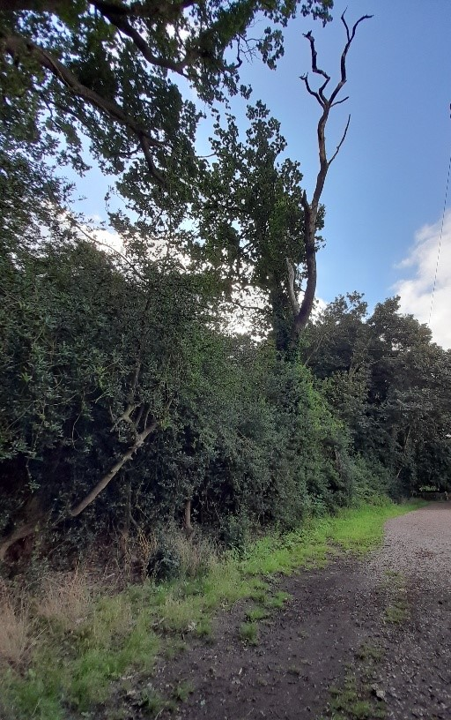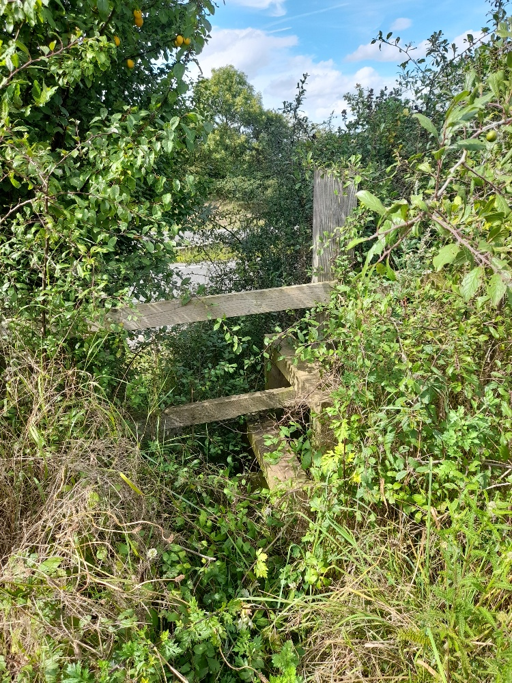
Dead branch over FP10 Stile at end of FP7

March Update
The weather has been very wet over the winter months and this has made the footpaths very soft and muddy, however all are easily accessible. For instance the continuation of the Church Alley footpath Blofield 10 has become deeply rutted and walkers have had to go further into the undergrowth at the side of the path to find firmer ground and this is usually a firm footpath!
‘FP3. From Shack Lane the path around Woodlands Manor is clear and the way through to the field is obvious. As has been mentioned in the past, once on the field there is no indication where to go and it has been planted with a cereal crop making no allowance for the footpath. The finger post at the Holly Lane end is at a jaunty angle and does not give a clear direction how to cross the field. From Shack Lane up the steps to the A47 is passable but will be difficult once the brambles start their summer growth. The stile is slightly wobbly but usable and the entrance on the opposite side of the A47 is obvious if anyone wanted to cross.
FP4 along the top of the A47 from Yarmouth Road to Plantation Road has been thoroughly trimmed on each side but again regrowth will probably impede this in summer. The footpath is on an angle in places sloping down towards the road.
FP5 & 7. Now Herondale Estate and the original footpaths incorporated into the roadways. The area leading to the crossing of the A47 is clear and being reseeded. The stile is still in position.
FP8. Parallel to Garden Road. Has been cleared and is passable but holly and nettles have already started to regrow, always a problem in summer. FP12. The last three planks leading downhill to the stream are moving under foot and this has been worsened by the wet weather this winter. Although usable not ideal.’
Tricia Dolamore 13.3.24
We have had some good news from the NCC Parish Partnership scheme in that Footpath 12 between the entrance to Marty’s Marsh and the small bridge over the Run is to be improved from the existing netting covered two parallel sleepers to a wider firmer path during the year 24/25.
Yvonne Burton 14.3.24

- KEEP BLOFIELD SPECIAL REPORT (prepared by Peter Mackness and read by Sarah Osbaldeston)
Keep Blofield Special is a small group of volunteers who undertake litter-picking for an hour or so on the first and second Mondays of each month in our two villages.
We have had another full year of monthly litter-picks and, as usual, we find mainly take-away food packaging and drink cans/bottles. It is “low-level litter” but unsightly nonetheless – we hope that by picking it up regularly it will discourage further littering.
One of the regular Blofield hot-spots over the years was Waterlow which had three “unofficial” lay-bys always generating plenty of litter. Waterlow is now closed for the A47 scheme and, so far, the litter problem does not seem to have been increasing elsewhere.
From time to time we come across larger items, usually DIY waste, which we report using the on-line Fly tipping Report Form. Broadland’s response has, as always, been excellent.
The bank between the Library and Blofield School which was prepared and planted by KBS a few years ago continues to provide colour through the seasons.
The Spring daffodils donated several years ago and planted at the various entrances to the villages continue to bloom and add to the pleasant aspect of Blofield and Blofield Heath.
KBS is pleased to help keep our two villages looking attractive and always welcomes suggestions and new members. It is a very informal group of people and can be contacted via the Parish Clerk. KBS are not alone in collecting litter and we would like to thank others who also regularly collect litter around the village.

- TREE WARDENS REPORT (prepared and read by David Pilch)
  - During the past year the Blofield tree wardens have completed the following work;
  - Replaced around 12 dead oak tree saplings on the Wyngates site. The replacement oaks were supplied and donated by Ernest Hoyos, they have much better root structure and we expect them to thrive this year. During the work all the trees, stakes and guards at the Wyngates site were checked and repaired where necessary. Some additional mulch was applied where needed.
  - In celebration of the tree councils 50th year of being;
  - We were successful in our application for two orchard packs (ten trees), these are about to be planted in a group on the Wyngates site. They are a mixture of Apple, plum, gage and crab apple varieties. In line with the 50th anniversary they all contain “Golden” in their variety name. Some will be placed adjacent to a path so future foragers will enjoy the fruits of our labours.
  - Clearance work was undertaken at the bottom of Blofield churchyard, clearing up two fallen trees and bundles of brushwood placed into heaps to enhance wildlife habitat.
  - Four heritage apple trees have been saved from the chainsaw by successfully negotiating with highways England to relocate the 4 apple trees using a hydraulic tree spade. The trees near the A47 dualling construction site will be moved very soon to a more permanent location at the top of the allotments.
  - A very special disease resistant Elm tree has recently been planted on Marty's Marsh in an effort to re-establish much needed elm trees.
  - The "Diana tree" is outgrowing its cage and this will require attention soon. The tree wardens will assess this initially and deal with it if the remedy is simple.

- BLOFIELD ORCHARD CONSERVATION PROJECT REPORT (prepared and read by Richard Codling)
  - The orchard conservation project celebrates its 10th anniversary this year and it continues to be a great asset to the village. The collection of rare fruit varieties now number some 80 trees. This year we added a medlar, peach, two cherries and two more apple trees.
  - Work parties were held on most Tuesday mornings with 6 to 8 people attending. We carried out various skills including pruning, fruit thinning, scything, weeding and mulching around the trees.
  - The fruit harvest was very poor this year, this was mostly due to cold and damp weather during blossom time. Honey bees are reluctant to venture out at temperatures below 13 degrees centigrade. So a change in bees is needed. This coming blossom time we will be releasing 50 red mason bees to assist with pollination. A single red mason bee is 250 times more productive than a honey bee. We have installed a few nesting sites to encourage the Red mason bees to stay in the orchard.
  - There seems to be more butterflies each year in the orchard, we think this is due to leaving areas of the sward uncut and spot planting of butterfly friendly plants like wild marjoram. Muntjac deer regularly visit the orchard and a large hare was seen recently. Some hedging is deliberately only cut every two years allowing the hedge to produce nuts and berries which in turn helps the birdlife.
  - In October we had our annual stall at the shoulder of mutton apple day, where we sold a good proportion of our pears and apples. This event is our main way of raising funds for the orchard. The orchard accounts are quite healthy and we continue to buy specialist equipment like secateurs and pruning saws.
  - During spring we developed a trial system of watering only certain trees, mostly Blofield Russet to see if any difference occurred in fruit size and fruit health. The trees were watered with 5 gallons every week. Come harvest time we noticed the fruit size to be bigger and no cracking of the fruit. So, the trial worked.
  - Anyone who wishes to visit the orchard or wants to help the group please contact Richard via the parish clerk.

- Blofield Fuel Charity Report (prepared by the charity clerk Sarah Russen and read by Sarah Osbaldeston)
  - This is our yearly report for the Blofield Fuel Charity. This Charity was set up in the 1800`s for the Needy and the Poor of the Villages of Blofield and Blofield Heath. The money was towards their use of coal for their heating, but as we all know now, how things have changed and it is now towards their heating bills and the applicants can use it as they see fit.
  - The Charity owns 27 Acres of farm land, in the area of Blofield Heath and is leased out to two farmers who pay the Charity twice yearly income a total of £2,770.00 and we also have a Wayleave from UK. Power, who have power pylons across our land and pay us £171.71p a year. This is our main income and we distribute it amongst the applicants, who have applied by filling in an application from they can collect from Blofield newsagents and Blofield Heath Post office in September of each year. The stipulations are that the Applicants must have lived in the villages for more than 7 years and are over the age of 65.
  - This year has been another good year for the 40 applicants, as we were able to give out £100.00 to a single person and £80.00 to a couple. The Trustees are made up of five Trustees ,who are appointed by the Parish Council and a Clerk and meet twice a year to discuss any issues and to decide how much the Charity can distribute to the applicants. This monies were gratefully received by the applicants, as we had a few letters and calls to say so. The Charity would like to say``Thank You`` to the Parish Council for their continued support.

- BLOFIELD RELIEF IN NEED CHARITY / REVE EDUCATION FOUNDATION REPORT (prepared by Debbie Smith and read by Sarah Osbaldeston)
The Trustees of The Reve Educational Foundation and Blofield Relief-In-Need Charity were pleased to be able to make three grants over the past year. These included one for educational purposes of £500 and one to the Acle Food Bank of £400 towards Christmas food/presents etc. for Blofield families who are assisted by the Food Bank. A further grant of £300 was made to a resident who was in need to assist with moving costs.

- BLOFIELD CHURCH REPORT (read by Rev. Kevin Bilson)
Blofield church continues to have two regular weekly services. These services are a combination of eucharistic and non-eucharistic services.
A commemorative service of Evensong was held in the church on Sunday 7th May to mark the Coronation of King Charles III at which a deputy Lord-Lieutenant was in attendance. This was preceded by a community afternoon tea, hosted with the kind support of a small grant from Blofield parish council. The annual service of remembrance on Sunday 12th November was held in the graveyard by the war memorial and continued in the Church.
‘Open doors’ the provision of a lunch time meal and two hours of cordial friendship takes place on the 1st and 3rd Thursday of each month. This is supported by volunteers and is much appreciated by those who attend. The Wednesday café meets every Wednesday morning after the service (10.15 -11.30 AM) and is visited regularly by members of the community.
The regular weekly play church activity, the term time baby and toddler group continues to be very popular with parents and carers.
The faculty has been granted to extend the area in the graveyard for cremation plots. This area will be to the east of the Lych-gate.
The church was able to meet its financial contribution to the diocese for mission and ministry in full last year, thanks to the generous giving of the congregation and local community support of fund-raising events.

- DISTRICT COUNCILLOR REPORT (prepared and read by Paul Newstead)
Parish Work
During the year I have worked with a number of parishioners and the Parish Council to provide support on planning issues and with traffic improvements.
I am supporting the link between Blofield Heath and Blofield, and the provision of a footpath between Blofield and Brundall on the old A47 Yarmouth Road. I have also worked with local agencies and charities (including Blofield & Brundall Men's Shed).
Some of my Ward Grants have been to local causes (Blofield Parish Council Play Equipment, BADCOG, Blofield Library).
I have also worked with our MP Jerome Mayhew to clarify the future of Hemblington Primary School.
Broadland District Council Update:
The annual budget of Broadland District council is £25.5M, which is used to support our 132,000 residents.
Over the next 14 years, our population is expected to increase by 12% (15,840) in Broadland, with an overall requirement for 18,500 new homes in the Greater Norwich area by 2026.
This challenging budget position and imminent large growth demands action now to make savings, optimise processes and prepare for an increased delivery of services.
Amongst the planned projects for 2024 -2025 are:
- New measures to improve our already high level of recycling.
- A new initiative to remove the current block on housing development through Nutrient Neutrality Credits.
- A new budget from the governing Political Coalition to increase funding through Council Tax
- A project to improve and modernise resident support through a range of online systems - "Customer Experience Programme”.
- The purchase of additional properties to address temporary accommodation issues in the Broadland area, supported by grants from central government.
- Continued development of the Affordable Housing strategy.
- Continued development of the Help Hub to support up to 3,500 resident enquiry cases annually.
- A review of the charging structure for a range of service fees to ensure full cost recovery from applicants, rather than subsidise these services by charges on all Council Taxpayers.
- New program to support apprenticeships.
- Recruitment of additional Planning Enforcement Officers to manage up to 150 cases per year.
If any parishioners would like to discuss any of these projects, or if I can help in any other way, please contact me via the Parish Council or by email at:
cllr.paul.newstead@southnorfolkandbroadland.gov.uk

- COUNTY COUNCILLOR REPORT (prepared by Andrew Proctor and read highlights by Sarah Osbaldeston)
  - The highlights are detailed below. The full document is attached as appendix A.
- 97.4% of highways inspections completed within timescale
- 96.8% of ‘Priority A’ defects (classified as dangerous/emergency) were fixed within the Transport Asset Management Plan timescales
- 95% Customer satisfaction (with Council Services)
- 96% of Looked after Children with an up-to-date Personal Education Plan
- Completed over 90,000 Adult Social Care Assessments for over 26,000 people

- TO HEAR AND DISCUSS ANY MATTERS RAISED BY MEMBERS OF THE PUBLIC
  - Paul Culley-Barber encouraged parishioners to report highways maintenance issues to NCC Highways through their website form.

- CLOSING COMMENTS
  - Sarah Dhesi thanked everyone for attending the meeting. There being no further business the meeting closed at 9:20pm.

Signed…………………….. Dated……………………….

